Manga (漫画)

Definition:
# Source: AI Source: Provided by: [Data Path: Persons Table -> ID Column: 1, Name_En Column: Motasem Essam] -> From: [ChatGPT] on [10/28/2025]
Manga are Japanese comic books or graphic novels that use sequential art to tell stories across a wide range of genres and audiences.
Manga (漫画) are Japanese illustrated stories told through a series of panels that combine art, dialogue, and narration — just like Western comics, but with distinct Japanese cultural styles and reading direction (right to left).
They can be action-packed adventures, romantic dramas, fantasies, comedies, or even slice-of-life stories — appealing to all ages and interests.

Key Features:
# Source: AI Source: Provided by: [Data Path: Persons Table -> ID Column: 1, Name_En Column: Motasem Essam] -> From: [ChatGPT] on [10/28/2025]
- Reading Direction: Read from right to left, both in panels and pages.
- Art Style: Often expressive, with large eyes, detailed backgrounds, and emotional emphasis.
- Serialization: Usually published chapter by chapter in weekly or monthly magazines before being collected in volumes (tankōbon).
- Genres:
  - Shōnen – for teen boys (e.g., Naruto, One Piece)
  - Shōjo – for teen girls (e.g., Sailor Moon, Fruits Basket)
  - Seinen – for adult men (e.g., Berserk, Tokyo Ghoul)
  - Josei – for adult women (e.g., Nana, Paradise Kiss)
- Themes: Friendship, adventure, love, conflict, fantasy, philosophy, daily life, and more.

Mangaka
# Source: AI Source: Provided by: [Data Path: Persons Table -> ID Column: 1, Name_En Column: Motasem Essam] -> From: [ChatGPT] on [10/28/2025]
A mangaka is a manga artist — the person who creates, writes, and draws manga.
In Japanese:
- “Manga” (漫画) = comics
- “-ka” (家) = suffix meaning professional, creator, or specialist
So, Mangaka (漫画家) literally means “manga creator” or “manga professional.”

What a Mangaka Does:
A mangaka usually handles:
- ✍️ Story writing (plot, dialogue, pacing)
- 🎨 Drawing / illustration (characters, backgrounds)
- 🧠 Character design
- 🗓️ Planning chapters / volumes
- 👥 Working with assistants for inking, tones, and effects
- 📰 Publishing through a manga magazine (like Shonen Jump or Weekly Shonen Magazine)

Famous Mangaka Examples:
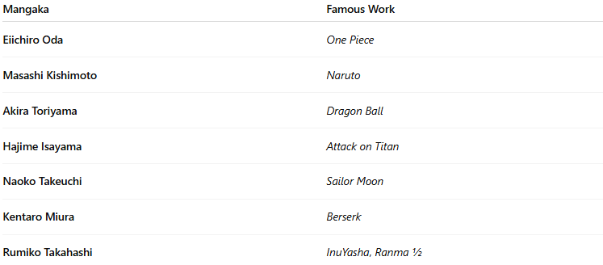
Mangaka | Famous Work
Eiichiro Oda | One Piece
Masashi Kishimoto | Naruto
Akira Toriyama | Dragon Ball
Hajime Isayama | Attack on Titan
Naoko Takeuchi | Sailor Moon
Kentaro Miura | Berserk
Rumiko Takahashi | InuYasha, Ranma ½

🧠 In Short:
Mangaka = The author and artist who creates manga.
Some mangaka work alone, while others have teams of assistants and editors helping them publish chapters regularly.

Famous Examples:
# Source: AI Source: Provided by: [Data Path: Persons Table -> ID Column: 1, Name_En Column: Motasem Essam] -> From: [ChatGPT] on [10/28/2025]
- Naruto by Masashi Kishimoto
- One Piece by Eiichiro Oda
- Attack on Titan by Hajime Isayama
- Death Note by Tsugumi Ohba and Takeshi Obata
- Demon Slayer (Kimetsu no Yaiba) by Koyoharu Gotouge

Chapter
# Source: AI Source: Provided by: [Data Path: Persons Table -> ID Column: 1, Name_En Column: Motasem Essam] -> From: [ChatGPT] on [10/28/2025]
A chapter in a manga is a single unit or installment of the story — similar to a TV episode in a series or a chapter in a novel.
Each chapter contains a sequence of illustrated pages (usually black and white) that together tell a continuous part of the storyline, including dialogue, action, and emotion through both art and text.

🔹 Detailed Breakdown
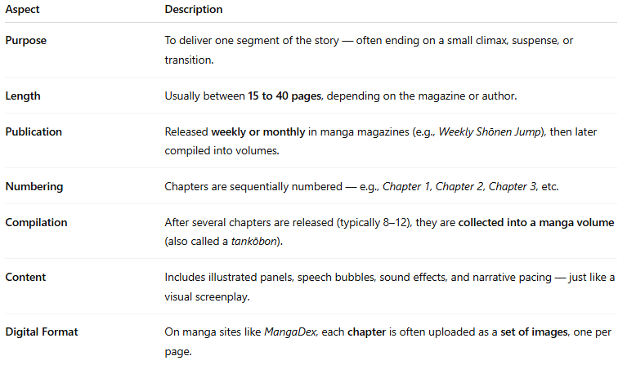
Aspect | Description
Purpose | To deliver one segment of the story — often ending on a small climax, suspense, or transition.
Length | Usually between 15 to 40 pages, depending on the magazine or author.
Publication | Released weekly or monthly in manga magazines (e.g., Weekly Shōnen Jump), then later compiled into volumes.
Numbering | Chapters are sequentially numbered — e.g., Chapter 1, Chapter 2, Chapter 3, etc.
Compilation | After several chapters are released (typically 8–12), they are collected into a manga volume (also called a tankōbon).
Content | Includes illustrated panels, speech bubbles, sound effects, and narrative pacing — just like a visual screenplay.
Digital Format | On manga sites like MangaDex, each chapter is often uploaded as a set of images, one per page.

📖 Example
- One Piece — Chapter 1110: “The World Trembles”
→ Contains ~20 pages, focuses on one specific part of the story, and continues in Chapter 1111.

Volume
# Source: AI Source: Provided by: [Data Path: Persons Table -> ID Column: 1, Name_En Column: Motasem Essam] -> From: [ChatGPT] on [10/28/2025]
A manga volume — often called a tankōbon (単行本) in Japanese — is a book-length collection of several manga chapters that have already been published individually (for example, in weekly or monthly magazines).
Think of a volume as a “season” of episodes or a chapter bundle — it gathers multiple chapters into one organized, permanent book.

🔹 Detailed Breakdown
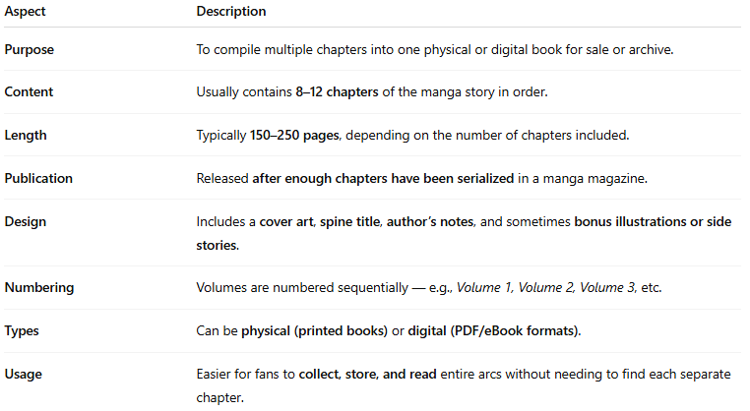
Aspect | Description
Purpose | To compile multiple chapters into one physical or digital book for sale or archive.
Content | Usually contains 8–12 chapters of the manga story in order.
Length | Typically 150–250 pages, depending on the number of chapters included.
Publication | Released after enough chapters have been serialized in a manga magazine.
Design | Includes a cover art, spine title, author’s notes, and sometimes bonus illustrations or side stories.
Numbering | Volumes are numbered sequentially — e.g., Volume 1, Volume 2, Volume 3, etc.
Types | Can be physical (printed books) or digital (PDF/eBook formats).
Usage | Easier for fans to collect, store, and read entire arcs without needing to find each separate chapter.

📖 Example
- Naruto Volume 1 includes Chapters 1–7, covering the introduction of Naruto and his ninja academy story.
- Attack on Titan Volume 10 includes Chapters 39–42, focusing on a key part of the plot arc.

🔸 In Short
- Chapter = one episode of the story.
- Volume = a book that collects several chapters together.

Plot
# Source: AI Source: Provided by: [Data Path: Persons Table -> ID Column: 1, Name_En Column: Motasem Essam] -> From: [ChatGPT] on [10/28/2025]
1. Definition
the plot refers to the sequence of events and storyline that drives the narrative. It’s essentially what happens in the story from beginning to end.

Plot = The structured series of events in a manga that create conflict, development, and resolution.
- It answers questions like:
  - Who is the story about? (Characters)
  - What challenges or goals do they face? (Conflict/Goals)
  - How does the story progress? (Events / Turning Points)
  - How does it end? (Resolution / Outcome)

2. Components of a Plot in Manga
- Exposition
  - Introduces characters, setting, and basic situation.
  - Example: A high school student discovers they have magical powers.
- Rising Action
  - Events that build tension and develop the story.
  - Example: The protagonist faces challenges, meets allies/enemies, or uncovers secrets.
- Climax
  - The most intense or decisive point in the story.
  - Example: Final battle, critical decision, or turning point.
- Falling Action
  - Events after the climax showing consequences of actions.
  - Example: The outcome of a battle, resolution of conflicts, or character growth.
- Resolution / Denouement
  - The story concludes, conflicts are resolved, and loose ends are tied up.
  - Example: Characters return to normal life, or the world is permanently changed.

3. Additional Notes for Manga
- Manga plots often have long arcs, especially in shonen/seinen genres, where a single volume may cover part of a larger storyline.
- Side stories or filler chapters may exist, but the plot refers to the main sequence of events.
- Plot can also include subplots, such as romance, friendship, or side conflicts.

✅ Summary
- Plot in manga = The story’s events, structure, and sequence that guide the narrative.
- Key elements: Exposition → Rising Action → Climax → Falling Action → Resolution
- Manga may have arcs, subplots, and filler chapters, but the plot refers to the main story line.

Characters
# Source: AI Source: Provided by: [Data Path: Persons Table -> ID Column: 1, Name_En Column: Motasem Essam] -> From: [ChatGPT] on [10/28/2025]
1. Definition
In manga, characters are the people, creatures, or beings who drive the story and interact within the plot. They are essential because the plot revolves around their actions, decisions, and development.
Characters in manga = The individuals who perform actions, face challenges, and experience growth within the story.
They can be:
- Protagonists → Main character(s) driving the story
- Antagonists → Opposing forces or villains creating conflict
- Supporting characters → Friends, mentors, sidekicks, or secondary characters who support or influence the main story

2. Types of Characters
- Main Characters (Protagonists)
  - Central to the story’s plot.
  - Often undergo development or growth.
  - Example: Naruto in Naruto, Luffy in One Piece.
- Villains / Antagonists
  - Create conflict or obstacles for the protagonist.
  - Can be complex with their own motives.
  - Example: Orochimaru in Naruto, Akainu in One Piece.
- Supporting Characters
  - Help or challenge the main characters.
  - Can add humor, romance, or emotional depth.
  - Example: Sakura in Naruto, Nami in One Piece.
- Side Characters / Extras
  - Minor roles but can enrich the world.
  - Example: Townspeople, classmates, minor enemies.
- Dynamic vs Static Characters
  - Dynamic: Change or grow throughout the story (character development).
  - Static: Stay mostly the same, providing consistency or contrast.

3. Character Attributes in Manga
- Appearance: Hairstyle, clothing, unique features
- Personality: Traits like brave, cunning, cheerful, or shy
- Motivation: Goals, desires, or reasons behind their actions
- Relationships: Connections with other characters
- Abilities / Powers: Special skills, magic, or fighting techniques (common in shonen or fantasy manga)

✅ Summary
- Characters are the driving force of a manga’s story.
- Include protagonists, antagonists, supporting characters, and extras.
- Can be dynamic (changing) or static (unchanging).
- Attributes like appearance, personality, motivation, relationships, and powers make them memorable and define their role in the plot.

MANGA TYPES

General Manga Genres
# Source: AI Source: Provided by: [Data Path: Persons Table -> ID Column: 1, Name_En Column: Motasem Essam] -> From: [ChatGPT] on [10/28/2025]
1. Shōnen (少年)
Target: Teen boys (around ages 12–18)
Features: Action, adventure, friendship, training, courage, humor
Examples:
- Naruto
- One Piece
- Dragon Ball
- My Hero Academia

2. Shōjo (少女)
Target: Teen girls (around ages 12–18)
Features: Romance, emotions, relationships, drama, fantasy
Examples:
- Sailor Moon
- Fruits Basket
- Cardcaptor Sakura
- Ouran High School Host Club

3. Seinen (青年)
Target: Adult men (ages 18+)
Features: Mature themes, violence, psychological depth, realism
Examples:
- Berserk
- Tokyo Ghoul:re
- Vinland Saga
- Attack on Titan (later arcs lean toward seinen)

4. Josei (女性)
Target: Adult women (ages 18+)
Features: Realistic romance, life problems, drama, relationships
Examples:
- Nana
- Paradise Kiss
- Honey and Clover
- Chihayafuru

5. Kodomo (子供)
Target: Children (under 12)
Features: Simple stories, humor, moral lessons, fun adventures
Examples:
- Doraemon
- Hello Kitty
- Pokémon Adventures
- Hamtaro

6. Isekai (異世界)
Focus: Characters transported or reborn in another world
Examples:
- Re:Zero
- That Time I Got Reincarnated as a Slime
- Sword Art Online
- Konosuba

7. Slice of Life
Focus: Everyday life, realism, simple daily experiences
Examples:
- Barakamon
- K-On!
- Silver Spoon
- Laid-Back Camp

8. Psychological
Focus: Mind games, emotions, mental conflict, human nature
Examples:
- Death Note
- Monster
- Psycho-Pass
- Paranoia Agent

9. Mecha (メカ)
Focus: Robots, machines, futuristic warfare, pilots
Examples:
- Neon Genesis Evangelion
- Code Geass
- Mobile Suit Gundam
- Darling in the FranXX

10. Military
Focus: War, soldiers, strategy, military life
Examples:
- Attack on Titan
- Fullmetal Alchemist
- The Saga of Tanya the Evil
- Gate: Thus the JSDF Fought There!

11. School Life
Focus: Daily school experiences, friendships, romance, student life
Examples:
- Horimiya
- K-On!
- Assassination Classroom
- My Teen Romantic Comedy SNAFU

12. Post-Apocalyptic / Dystopian
Focus: Ruined societies, survival after disasters or war
Examples:
- Akira
- Attack on Titan
- Blame!
- Coppelion

13. Cyberpunk
Focus: High-tech, low-life, futuristic dystopia, hacking
Examples:
- Ghost in the Shell
- Akira
- Ergo Proxy
- Blame!

14. Action
Focus: Fights, battles, power, adventure, survival
Examples:
- One Punch Man
- Attack on Titan
- Bleach
- Demon Slayer

15. Adventure
Focus: Exploration, journeys, quests, discovery of new worlds
Examples:
- One Piece
- Hunter × Hunter
- Made in Abyss
- Fairy Tail

16. Comedy
Focus: Humor, funny situations, lighthearted tone
Examples:
- Gintama
- Nichijou
- Kaguya-sama: Love Is War
- The Disastrous Life of Saiki K.

17. Parody
Focus: Comedy that imitates or mocks other anime/manga genres
Examples:
- Gintama
- One Punch Man
- Excel Saga
- Pop Team Epic

18. Drama
Focus: Emotional tension, realistic conflict, character development
Examples:
- Your Lie in April
- Clannad
- Orange
- March Comes in Like a Lion

19. Tragedy
Focus: Sad endings, loss, death, emotional pain
Examples:
- Your Lie in April
- Grave of the Fireflies
- Elfen Lied
- A Silent Voice

20. Romance
Focus: Love stories, relationships, emotional growth
Examples:
- Toradora!
- Ao Haru Ride
- My Dress-Up Darling
- Kimi ni Todoke

21. Fantasy
Focus: Magic, mythical worlds, supernatural creatures
Examples:
- Black Clover
- Fairy Tail
- Magi: The Labyrinth of Magic
- The Seven Deadly Sins

22. Science Fiction (Sci-Fi)
Focus: Technology, future worlds, space, robotics
Examples:
- Steins;Gate
- Ghost in the Shell
- Planetes
- Akira

23. Horror
Focus: Fear, suspense, death, psychological terror
Examples:
- Tokyo Ghoul
- Another
- Parasyte
- Uzumaki

24. Mystery
Focus: Solving crimes, uncovering secrets, investigations
Examples:
- Death Note
- Detective Conan
- Monster
- Erased

25. Mystery Thriller / Crime
Focus: Suspense, detective stories, criminal psychology
Examples:
- Death Note
- 20th Century Boys
- Erased
- Pluto

26. Detective
Focus: Investigation, logic, solving mysteries
Examples:
- Detective Conan
- The Kindaichi Case Files
- Death Note
- Pluto

27. Sports
Focus: Teamwork, training, competition, determination
Examples:
- Haikyuu!!
- Blue Lock
- Slam Dunk
- Ace of Diamond

28. Game / Esports
Focus: Video games, competitions, online worlds
Examples:
- No Game No Life
- Sword Art Online
- The King's Avatar
- Log Horizon

29. Cooking / Gourmet
Focus: Food, cooking battles, recipes, culinary passion
Examples:
- Food Wars! (Shokugeki no Soma)
- Sweetness and Lightning
- Yakitate!! Japan
- Oishinbo

30. Music
Focus: Bands, idols, singing, instruments, passion for music
Examples:
- Your Lie in April
- Beck: Mongolian Chop Squad
- Given
- Nana

31. Historical
Focus: Past eras, samurai, ancient times, real events
Examples:
- Rurouni Kenshin
- Vinland Saga
- Kingdom
- Golden Kamuy

32. Mythology / Folklore
Focus: Gods, spirits, ancient myths, cultural legends
Examples:
- Noragami
- InuYasha
- Nura: Rise of the Yokai Clan
- Record of Ragnarok

33. Supernatural
Focus: Ghosts, spirits, powers beyond science
Examples:
- Jujutsu Kaisen
- Bleach
- Noragami
- Blue Exorcist

34. Vampire
Focus: Vampires, immortality, gothic romance
Examples:
- Vampire Knight
- Hellsing
- Blood+
- Seraph of the End

35. Martial Arts
Focus: Physical combat, fighting styles, tournaments, training
Examples:
- Baki
- Hajime no Ippo
- Kenichi: The Mightiest Disciple
- Kengan Ashura

36. Magical Girl (Mahō Shōjo / 魔法少女)
Focus: Girls with magical powers fighting evil
Examples:
- Sailor Moon
- Madoka Magica
- Cardcaptor Sakura
- Tokyo Mew Mew

37. Harem
Focus: One male protagonist surrounded by many female characters
Examples:
- The Quintessential Quintuplets
- High School DxD
- Nisekoi
- Love Hina

38. Reverse Harem
Focus: One female protagonist surrounded by many male characters
Examples:
- Ouran High School Host Club
- Fruits Basket
- Kamisama Kiss
- Yona of the Dawn

Sexual Manga Genres
# Source: AI Source: Provided by: [Data Path: Persons Table -> ID Column: 1, Name_En Column: Motasem Essam] -> From: [ChatGPT] on [10/28/2025]
1. Shōnen-ai (少年愛)
Focus: Emotional or romantic relationships between male characters; gentle and non-explicit tone
Notes:
- The term literally means “boy’s love” but emphasizes romance and emotion, not sexuality.
- Often considered the soft version of Yaoi / BL.
- Focuses on emotional bonds, innocence, and relationship development.
Examples:
• Gravitation
• Loveless
• Antique Bakery
• Gakuen Heaven

2. Shōjo-ai (少女愛)
Focus: Emotional or romantic relationships between female characters; tender and non-explicit tone
Notes:
- Literally “girl’s love,” but focuses on romance, friendship, and emotional growth rather than sexual content.
- Considered the soft version of Yuri / GL.
Examples:
• Maria-sama ga Miteru
• Strawberry Panic
• Bloom Into You
• Sakura Trick

3. Yaoi (BL – Boys’ Love)
Focus: Romantic or emotional relationships between men
Examples:
- Junjou Romantica
- Given
- Sekaiichi Hatsukoi
- Banana Fish

4. Yuri (GL – Girls’ Love)
Focus: Romantic or emotional relationships between women
Examples:
- Citrus
- Bloom Into You
- Revolutionary Girl Utena
- Whispered Words

5. Ecchi (エッチ)
Focus: Light sexual humor, fanservice (not explicit)
Examples:
- High School DxD
- To Love Ru
- Prison School
- Rosario + Vampire

6. Hentai (変態)
Focus: Explicit adult content, sexual themes, and erotic fantasy (adults only)
Examples:
• Commonly referred to as “ero manga” in Japan
• Studied in academic fields like media censorship and gender representation
• Not publicly distributed in mainstream manga magazines

7. Seinen Erotic
Focus: Mature romantic and sexual themes aimed at adult men
Examples:
• Velvet Kiss
• Sundome
• Nana to Kaoru
• Nozoki Ana

8. Josei Erotic
Focus: Adult romance, emotional realism, and intimacy aimed at adult women
Examples:
• Midnight Secretary
• Happy Mania
• Desire Climax
• Anata ni Hana o Sasagemashou

In short:
# Source: AI Source: Provided by: [Data Path: Persons Table -> ID Column: 1, Name_En Column: Motasem Essam] -> From: [ChatGPT] on [10/28/2025]
Manga are Japanese comics that tell stories through unique art and cultural storytelling styles — blending visual art, character emotion, and narrative depth.

